**Get Drink**

You have a shopping robot and want to order some drinks from market.

Write a function to programme your robot. Give your directions from home to the market on console.

**1.**

To start, give your instructions with console.

**2.**

Create a function calcBottles that calculate how many drink robot can buy, according to the given amount of Money.

Function should accept total money as a first argument and per drink price second argument.

Return the number of bottles robot can buy.

Test the function by calling it multiple times and printing the results to the console.

**3.**

Now create a function calcChange to get the change after shopping. Function should accept same arguments as you did in step-3.

Return a string and the change amount.

**4.**

Finally, create a function getDrink that includes all instructions you give to the robot also how many drink robot should buy and change amount.

**5.**

Call your function with two arguments. Give different values and see the result.

For Example:

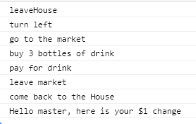

Congragulations !